process management

List out highest priority process in the system

# ps -elf^

# ps -eo pid,user,ppid,ni,cmd,%mem,%cpu --sort=-ni | tail -30

* –**e**         : Select all the process
* –**o**            : User defined format, ps allows to specify the output format.
* –**pid**        : Process ID list.
* –**ppid**     : Parent process ID
* -ni : user nice cpu time
* –**sort**      : Specify sorting order.
* **cmd**       : Command’
* %**cpu**     : CPU utilization of the process in “##.#” format.
* %**mem**  : Ration of the process’resident set size to the physical memory on the machine, displayed in percentage.

Note

* Linux and UNIX® systems use a priority system with 40 priorities, ranging from -20 (highest priority) to 19 (lowest priority.
* Processes started by regular users usually have priority 0.
* The ps command can display the priority (nice, or NI, level, for example) using the -l option.
* The nice command displays our default priority.

The nice command can also be used to start a process with a different priority.

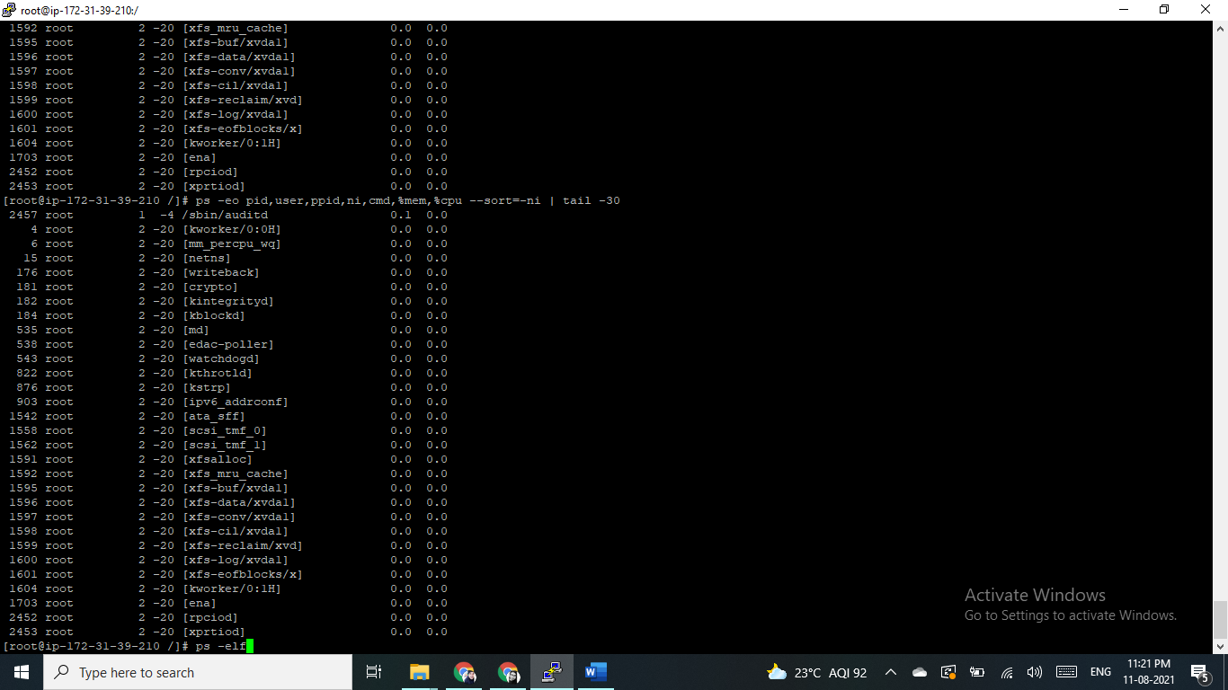

2) Open terminal with 2 tabs or sessions

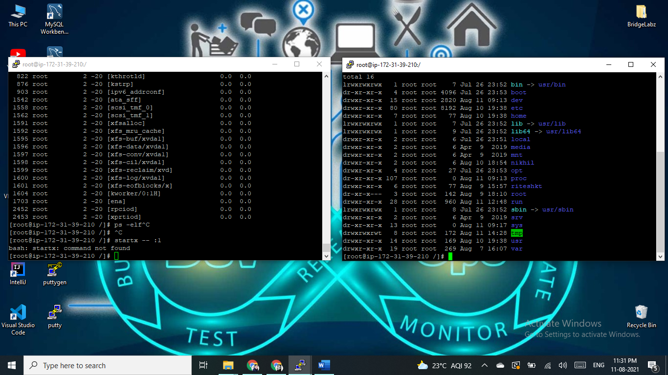

a) run command "vmstat 1"

*vmstat*command in Linux/Unix is a***performance monitoring command*** of the system as it gives the information about processes, memory, paging, block IO, disk, and CPU scheduling. All these functionalities makes the command *vmstat*also known as ***virtual memory statistic reporter***.

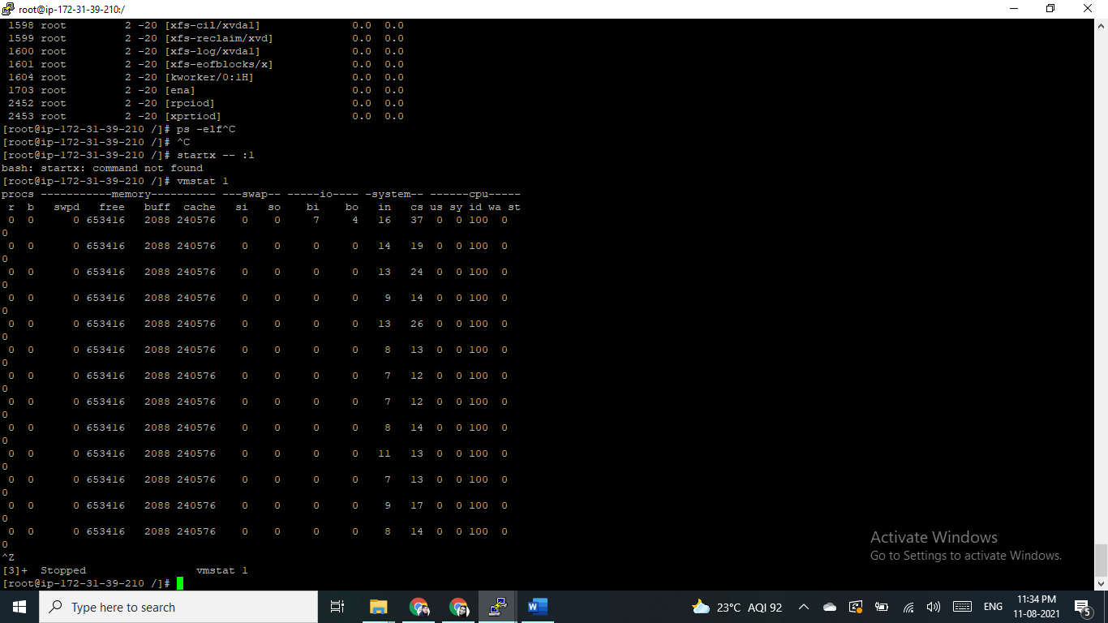

b) switch to another tab,  pause  running vmstat command for few seconds and resume it again, use appropriate SIGNALS to do this activity.

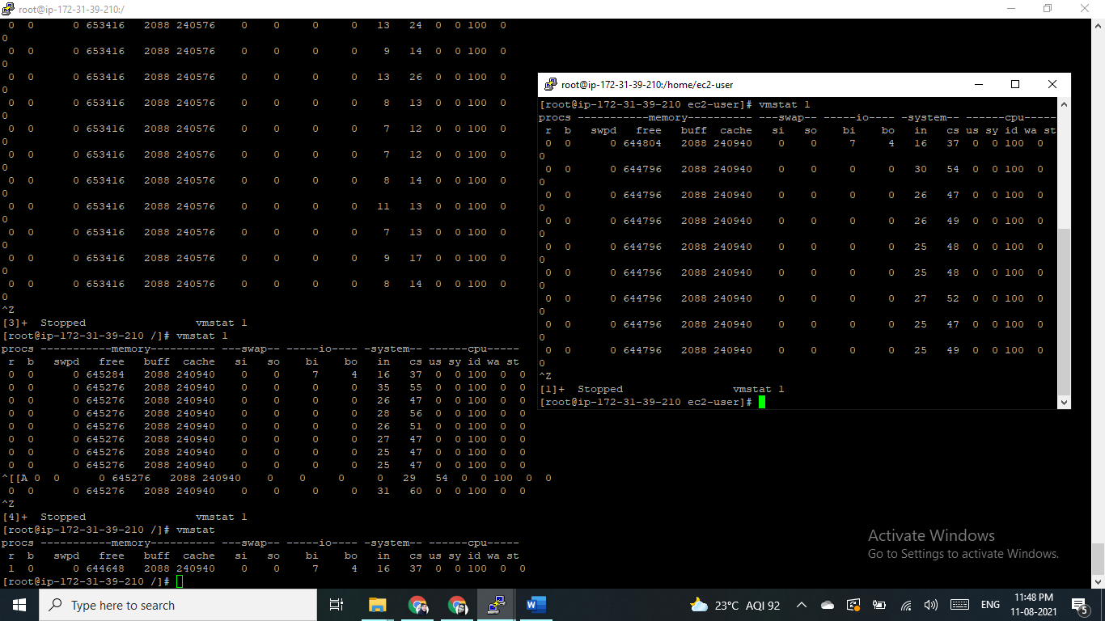

3)  Find the process which is sleeping in "wait" state.

**How to find the process state?**

You can find the process state from the following source:

a. Unix/Linux command-line tool ‘top’ will report the process state in the column ‘s’. Process status is reported with a single character.

**R** – RUNNING/RUNNABLE  
**S** – INTERRRUPTABLE_SLEEP  
**D** – UNINTERRUPTABLE_SLEEP  
**T** – STOPPED  
**Z** – ZOMBIE

Answer : ps -eo f,s,uid,pid,user,ppid,ni,cmd,%mem,%cpu --sort=s | tail -20

